Solar-powered Cell-phone Charging Station

Abstract
This proposal is to assemble and mount a solar-powered charging station at Eduardo J. Padron Campus. The system will include an LED that will notify students when the panel has enough energy to charge their devices. With this project, we will promote clean energy use on campus while encouraging other clubs to make the Padron Campus greater.

Introduction
Engineers for a Sustainable World Club at Eduardo J. Padron campus has the mission to empower students with an interest in engineering and to promote sustainability through education and engineering projects.
This semester we wanted to design and build an interactive project that is easy to use and could spark an interest in sustainability and clean energy. After going over various projects, we decided that a solar-powered cellphone charging station is the more suitable fit according to the campus’ need and the club’s monetary situation. We believe that our small contribution is a big step forward to a greener campus.

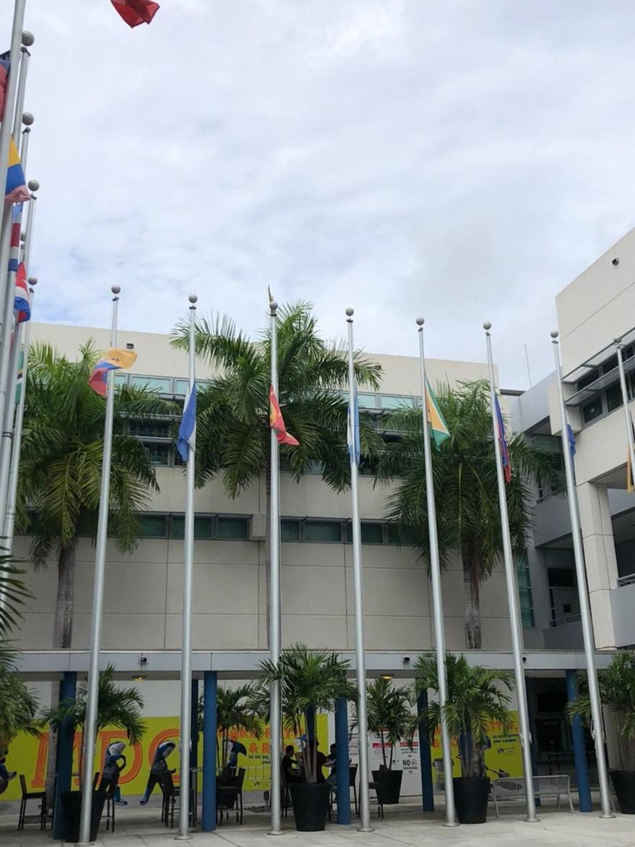
Eduardo J. Padron Campus, view of Building 1 from flag Courtyard.

Development and Placement
With the support of the Makers Lab and the physics department at Wolfson Campus, we have been working on this project for several weeks. We have sampled a couple of locations around campus to determine which has the best illumination, which would allow for the most efficient solar circuit possible. We have found that the roof above the hall between the flag courtyard and Building 1 is the best suit. The spot is spacious and receives good illumination during the day; in fact, it has the most daily exposure and intensity out of all the other sampled locations -roughly averaging 60,000 Lux on a sunny day. With this light intensity, we predict that the solar cell will be able to charge various electronic devices a day; achieving our goal of providing free green energy to the Padron Campus student body.

Equipment
-Solar Cell
-Two 12V 9A batteries
-Wire
-Solar Charge Controller
-LED lights
-Arduino UNO circuit board (for future implementations of sun-tracking feature)

Impact and Sustainability
Clean energy plays an essential role in the development of sustainable cities. It helps to conserve our natural resources while providing a reliable power supply.
We are proud supporters of the Sustainable Development Goals (SDGs). This project accentuates the SDGs of “Affordable and Clean Energy,” “Sustainable cities and communities,” and “ Climate Change.”
